

**You Might As Well**

**Be Walking On The Sun**

**“UCF steps into the future”**

The “Walking on the Sun” Group:

Brice McCoy

Daniel Simpson

Greg Boatright

Kyle Cartechine

**Table of Contents**

* **Team Member Information ...................................................................................................... 3**
* **Work Structure & Team Member Roles ................................................................................. 3**
* **Problem Statement .................................................................................................................... 4**
* **Assumptions ............................................................................................................................... 4**
* **Milestone Schedule ..................................................................................................................... 5**
* **Product Development Schedule ................................................................................................ 5**
* **Initial Design Draft .............................................................................................................. 6 - 8**
* **Necessary Equipment ................................................................................................................ 9**
* **List of Figures .......................................................................................................................... 10**
* **Key Imagery ...................................................................................................................... 11 - 13**
* **References ............................................................................................................................... 14**

**Team Member Information**

**Contact Information**

|  |  |  |
| --- | --- | --- |
| **Name** | **Email** | **Phone** |
| Brice McCoy | brice555@knights.ucf.edu | (386) 795-1343 |
| Daniel Simpson | danielsan@knights.ucf.edu | (305) 469-0218 |
| Greg Boatright | boatrightgreg@gmail.com | (954) 829-0132 |
| Kyle Cartechine | kcartechine@knights.ucf.edu | (321) 848-1960 |

**Team Member Roles/Strengths**

|  |  |  |  |  |  |  |
| --- | --- | --- | --- | --- | --- | --- |
| **Name** | **Artwork** | **Front End Design** | **Back End Design** | **Content Man.** | **Schedule** | **Budget?** |
| Kyle | X |  | X | X | X |  |
| Brice |  | X | X |  | X | X |
| Greg | X | X | X |  |  |  |
| Daniel | X | X | X |  |  |  |

**Problem Statement**

What if the UCF campus was part of a “smart-grid” of green technology that was powered by feet?

* Converting kinetic energy from footsteps into a renewable and sustainable energy source.
* How much energy could be generated and what can be done with it?

**Assumptions**

* There are over 55,000 students and over 10,000 faculty that walk around the campus at some point each day. With other staff, administration, and employees that makes over 100,000 sets of feet that can contribute renewable energy to a “smart-grid”.
* A “smart-grid” will be comprised of a series of networked surfaces utilizing piezoelectric tiles or pads to recover, convert and store kinetic energy.
* Individuals can be identified utilizing a unique RFID module attached to their person.
* The ideal places to implement the grid include walkways, hallways, sidewalks, doorways, and in various seating configurations (meaning not limited to just classrooms).
* The “smart-grid” technology will be modular in design and available in many form factors for the common household or community center within five years.
* This green technology will serve commercial and residential construction markets, foreign and domestic.
* It is possible to develop and deploy a “smart-grid” in a designated area on campus and have it fully operational by April 2013.

**Milestones and Schedule**

* Determine/Finalize Scope
* Finalize plan for deliver-ables
* Finish schedule
* Determine materials needed
* Complete/compile research
* SURE Application 2/15
* Finalize Branding
* Midterm
* Finish web app design/scripting
* Finish assembly
* Finalize presentation format
* Finish presentation
* SURE Event 4/5
* Final Presentation and Completion of this Document

**Product Development Schedule**

**Pre-production**

* Branding and artwork
* Finalize site design/layout
* Determine best method for prototype

**Production**

* Finish website
* Build prototype
* Integrate the pad with the site

**Post-production**

* Test pad within the group
* Test with larger audience - UCF students
* Surveys and other market research
* Show board design

**Initial Designs**

**Prototype Ideas**

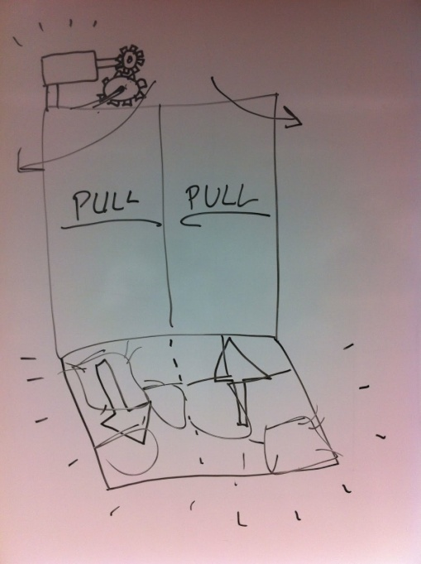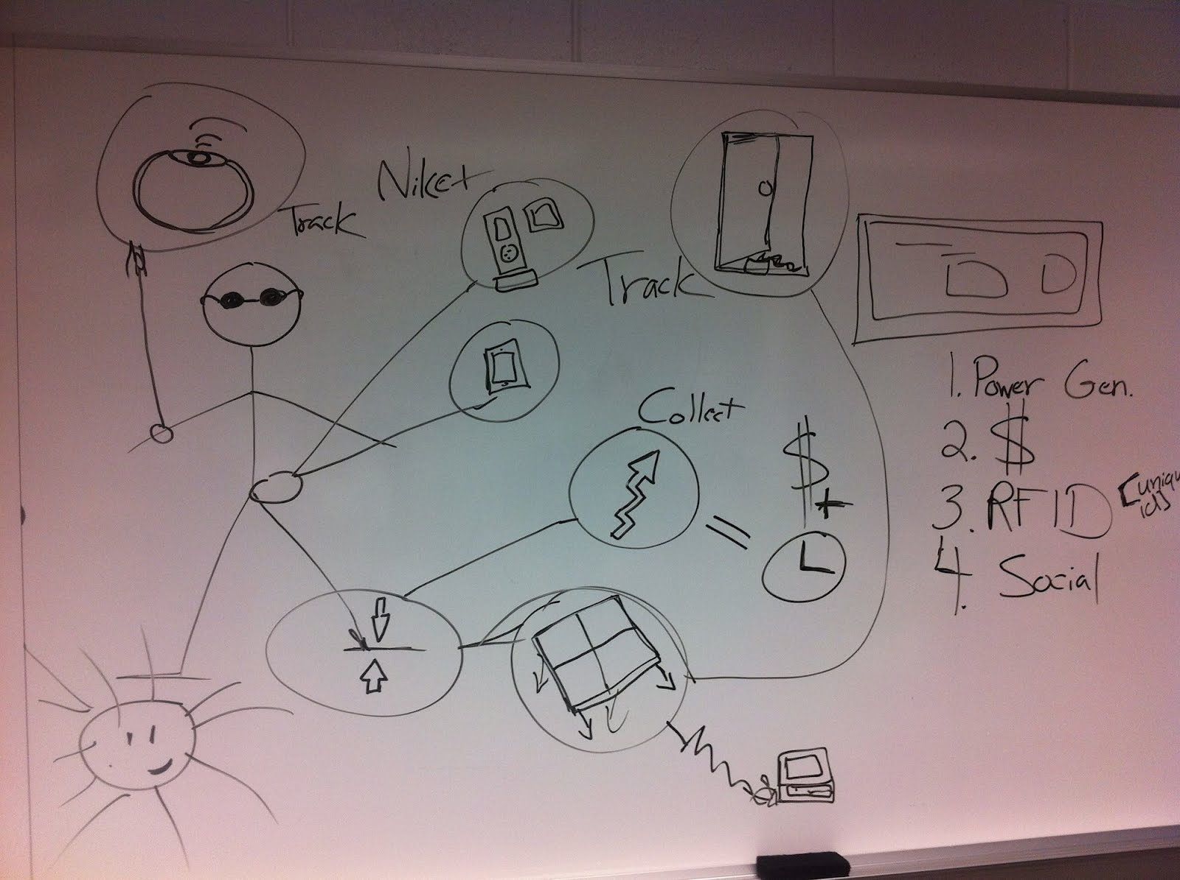

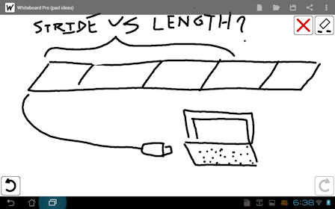

**Initial Design Ideas**

**Website**

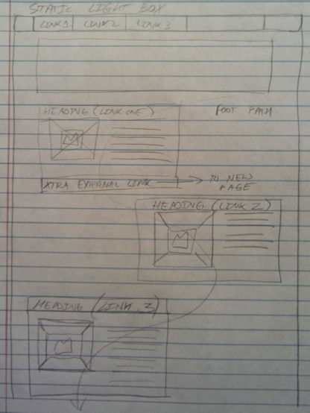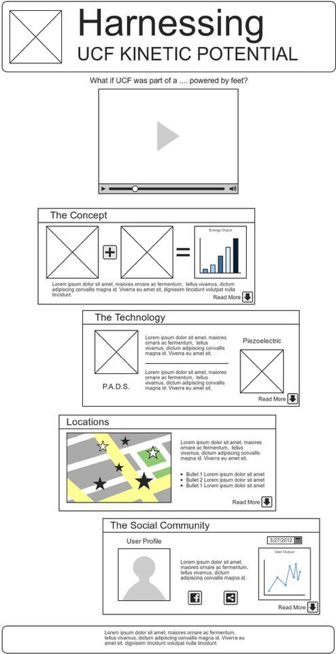

**Initial Design Ideas**

**Website**

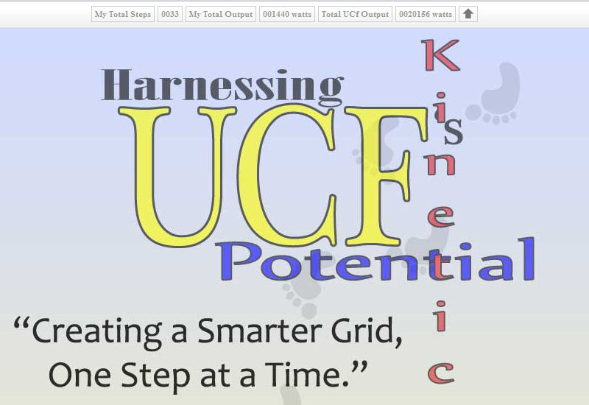

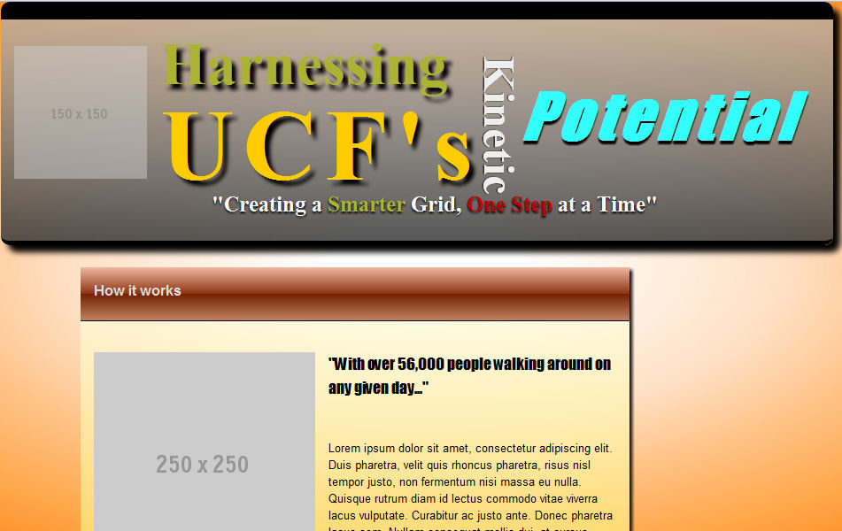**Necessary Equipment**

* soldering iron*
* saw*
* screws
* nails
* old computer keyboard
* copper wire
* copper film/foil
* tin wire
* foam pad
* carpet
* spray paint
* computer (laptop)
  + battery
  + power supply
  + power strip
  + power cable (50' +)
* science display board
* poster board
* paper

**List Of Figures (Budget = $180 Max)**

* [DDR Pad - $25-40]
* Foam mat (74”x24”) - $20.95
* Foil - $3
* Screws - $2
* Nails - $2
* Copper wire - $5
* Carpet/rug - $10
* Spray paint - $10
* Display board - $8
* Poster board - $2

Preliminary estimate: $62.95, assuming we are not using a DDR pad, and already have computers and power strips.

**Key Imagery**

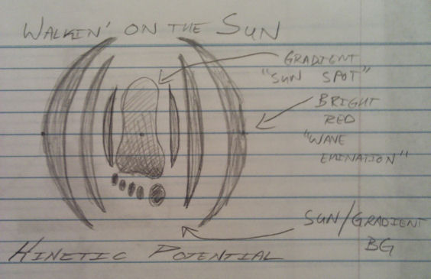

 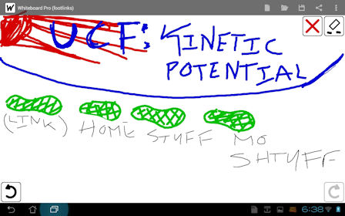

**Key Imagery**

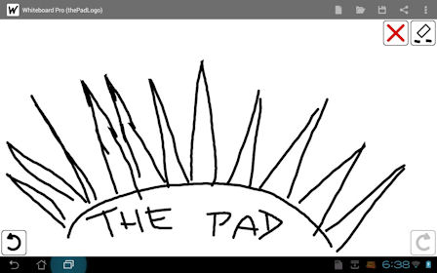

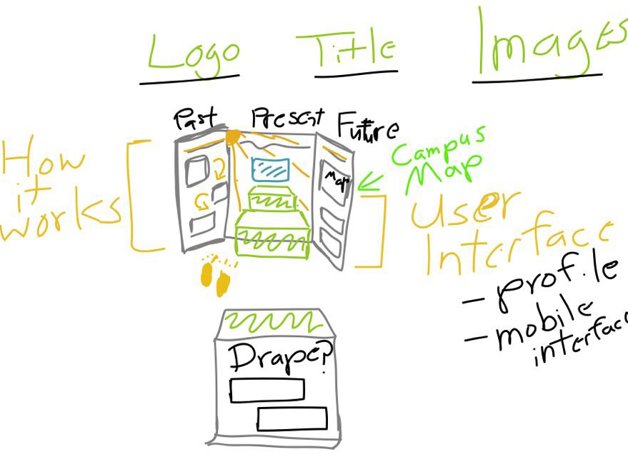

**Key Imagery**

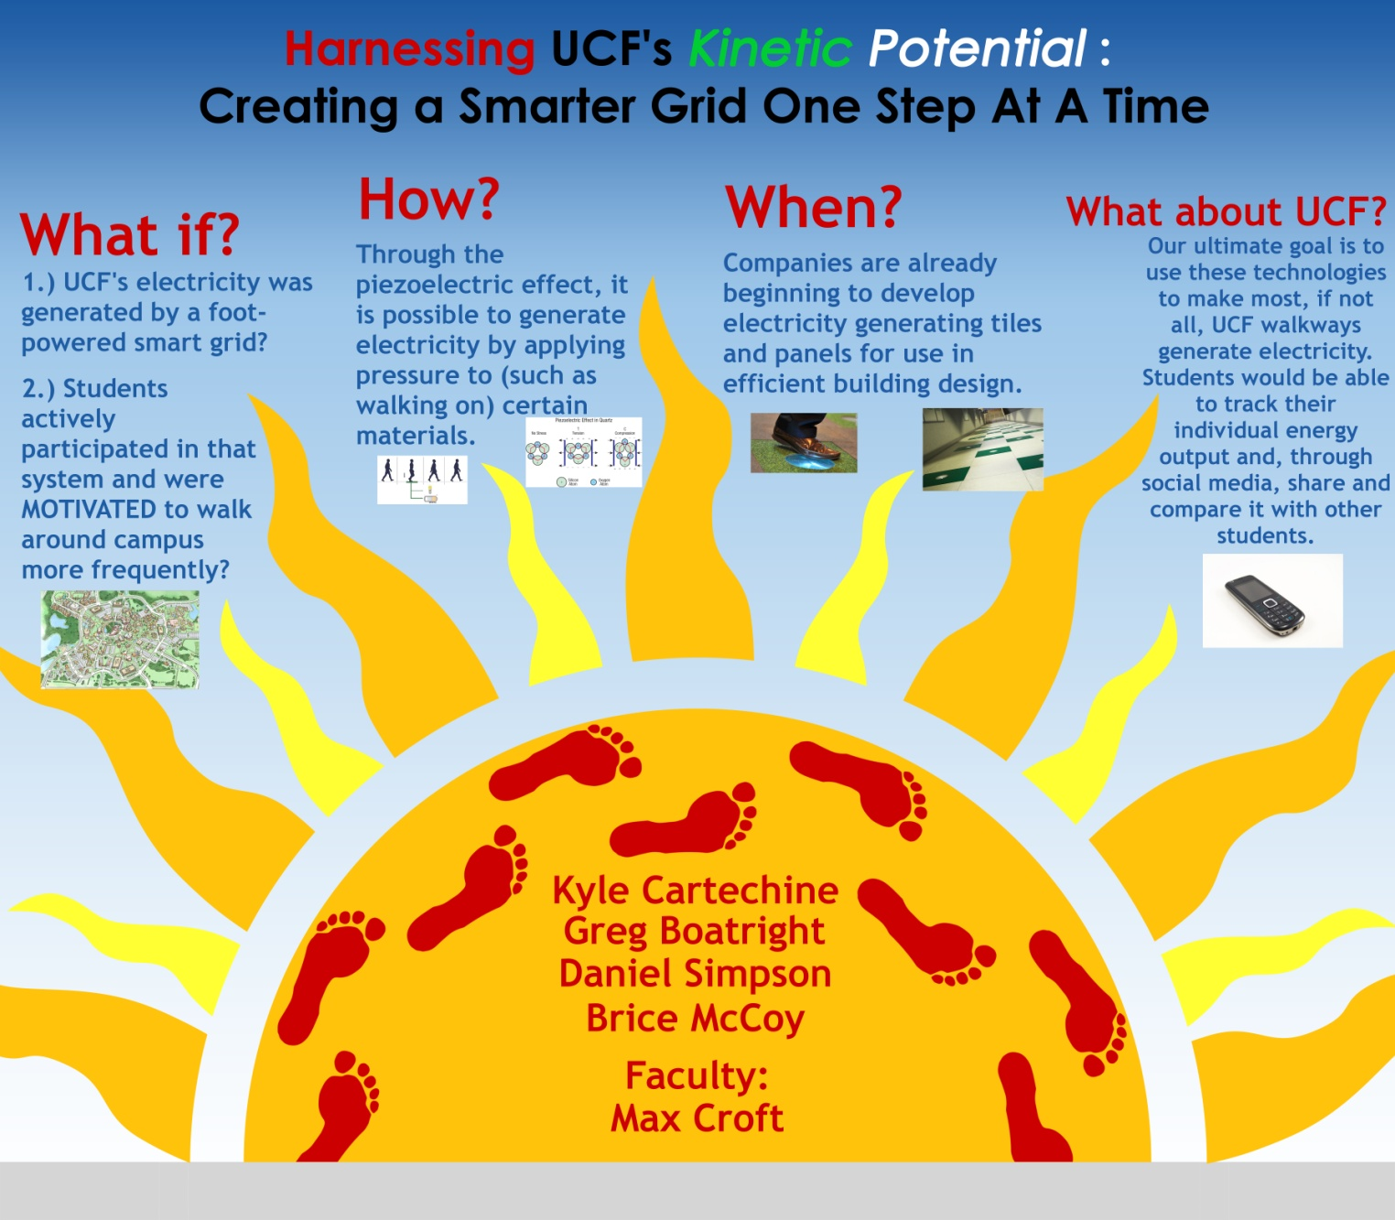

**References**

One Square Meter:

<http://ourworld.unu.edu/en/lets_generate_electricity_by_walking/>

Piezoelectric Technology

<http://en.wikipedia.org/wiki/Peizoelctric>

Generate Electricity by Walking

<http://emilychang.com/2009/01/generate-electricity-by-walking/>

PAVGEN Systems

<http://www.pavgen.com/>

<http://www.geekosystem.com/pavgen-sidewalk-tiles/>

Additional References

<http://www.alternative-energy-news.info/human-power-is-the-future/> <http://science.howstuffworks.com/environmental/green-science/house-music-energy-crisis1.htm>

<http://www.hughesresearch.co.uk/index.php>?

<http://spectrum.ieee.org/green-tech/mass-transit/startups-try-to-capture-road-traffics-excess-energy>

<http://www.technologyreview.com/energy/24428/>

<http://www.youtube.com/watch?v=Eam1-9FDD-Y>

<http://www.youtube.com/watch?v=YFITXmzB9EI&feature=related>

<http://www.amazon.com/CAP-Barbell-Anti-Microbial-piece-Puzzle/dp/B0041FQZMW/ref=sr_1_1?s=sporting-goods&ie=UTF8&qid=1330552669&sr=1-1>

<http://www.amazon.com/eWonderWorld-Thick-Multi-purpose-Gray-Mats/dp/B003TU3ZZU/ref=sr_1_6?s=sporting-goods&ie=UTF8&qid=1330552669&sr=1-6>

<http://www.amazon.com/YogaAccessories-Extra-Thick-Density-Phthalate/dp/B000PUIT0S/ref=sr_1_1?ie=UTF8&qid=1330552366&sr=8-1>